**If statement**

If is a conditional statement used to executed a block of code, in case of this condition is **true**; this condition can be written between two curve parentheses.

**Note:** We can use **And** logical operator (&&) to determine multiple conditions.

**Syntax:**

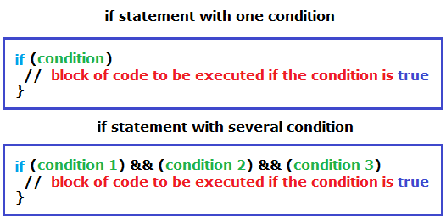

**Example:**

